**PHYSICS LAB-II**

**(2022 EVEN SEMESTER)**

**PBL**

**DIELECTRIC CONSTANT**

**Submitted by:**

DHRUV SINGHAL 9921103058

KAVIM GUPTA 9921103059

AAYUSHI GARG 9921103060



**Department of CSE/IT**

**Jaypee Institute of Information Technology University, Noida**

**MAY 2022**

**OBJECTIVE:**

To study the variation of dielectric constant with temperature and to find the Curie’s temperature of the given sample.

**FORMULA USED:**

The value of the dielectric constant ε, of the barium titanate sample is given by $=C/{C_{o}}$ where, C and $C_{o }$ are capacitance with and without the dielectric in between the plates.

**THEORY:**

Dielectric or electrical insulating materials are understood as the materials in which electrostatic fileds can persist for a long time. These materials offer a very high resisitance to the passage of electric current under the action of the applied direct-current voltage and therefore sharply differ in their basic electrical properties from conductive materials. Layers of such substances are commonly inserted into capacitors to improve their performance, and the term dielectric refers specifically to this application. The use of a dielectric in a capacitor presents several advantages. The simplest of these is that the conducting plates can be placed very close to one another without risk of contact. Also, if subjected to a very high electric field, any substance will ionize and become a conductor. Dielectrics are more resistant to ionization than air, so a capacitor containing a dielectric can be subjected to a higher voltage. Also, dielectrics increase the capacitance of the capacitor. An electric field polarizes the molecules of the dielectric (Figure-1), producing concentrations of charge on its surfaces that create an electric field opposed (antiparallel) to that of the capacitor. Thus, a given amount of charge produces a weaker field between the plates than it would without the dielectric, which reduces the electric potential. Considered in reverse, this argument means that, with a dielectric, a given electric potential causes the capacitor to accumulate a larger charge.

Barium Titanate (BaTiO3) has a ferroelectric tetragonal phase below its Curie point of about 120°C and paraelectric cubic phase above Curie point. The temperature of the Curie point appreciably depends on the impurities present in the sample and the synthesis process. In the paraelectric cubic phase the center of positive charges (Ba2+, Ti4+) coincide with the center of negative charges (0-2 ion) and on cooling below Tc, a tetragonal phase develops where the center of Ba2+ and Ti4+ ions are displaced relative to the 02- ions, leading to the formation of electric dipoles. 4 As the BT ceramics have a very large room temperature dielectric constant, they are mainly used in multilayer capacitor applications. The grain size control is very important for these applications.

The dielectric constant (ε) of a dielectric material can be defined as the ratio of the capacitance using that material as the dielectric in a capacitor to the capacitance using a vacuum as the dielectric.

**CODE:**

#include<iostream>

#include<algorithm>

using namespace std;

int main()

{

cout<<"-----------DIELECTRIC CONSTANT - CURIE TEMPERATURE-----------\n"<<endl;

cout<<"AIM: "<<endl;;

cout<<"To study the variation of dielectric constant with temperature and to find the Curie’s temperature of the given sample.\n"<<endl;

cout<<"APPARATUS USED: \nSample of barium titanate (BaTiO3) \nApparatus that includes probe arrangement \nSample \nOven \nOven controller \nDigital capacitance meter\n"<<endl;

cout<<"FORMULA USED: "<<endl;

cout<<"The value of the dielectric constant E, of the barium titanate sample is given by: "<<endl;

cout<<"E = C/C1"<<endl;

cout<<"where, C and C1 are capacitance with and without the dielectric in between the plates.\n"<<endl;

cout<<"------NOW IT's TIME FOR THE OBSERVATIONS------"<<endl;

cout<<"Input observations (Temperature in celsius and Capacitance in pF)"<<endl;

float temp[20];

float capa[20];

float dconst[20];

for(int i=0;i<20;i++){

cout<<"Enter temperature: ";

cin>>temp[i];

cout<<"Enter capacitance for the given temperature: ";

cin>>capa[i];

dconst[i]=capa[i]/(0.0299);

//cout<<"Dielectric constant: "<<dconst[i]<<endl<<endl;

}

cout<<"Observations (as input) : "<<endl;

cout<<"Temperature(C) | Capacitance(pF) | Dielectric constant"<<endl;

for(int j=0;j<7;j++){

cout<<temp[j]<<" | "<<capa[j]<<" | "<<dconst[j]<<endl;

}

for(int j=8;j<20;j++){

cout<<temp[j]<<" | "<<capa[j]<<" | "<<dconst[j]<<endl;

}

float max = *max_element(dconst, dconst+20);

int x;

for (int i = 0; i < 20; i++) {

if(dconst[i]==max){

x = i;

break;

}

}

cout<<"Maximum dielectric constant is : "<<dconst[x]<<endl;

cout<<"Temperature with maximum dielectric constant : "<<temp[x]<<endl;

cout<<"Result:"<<endl<<"The curie temperature is "<<temp[x];

return 0;

}

**OUTPUT**





**RESULT**

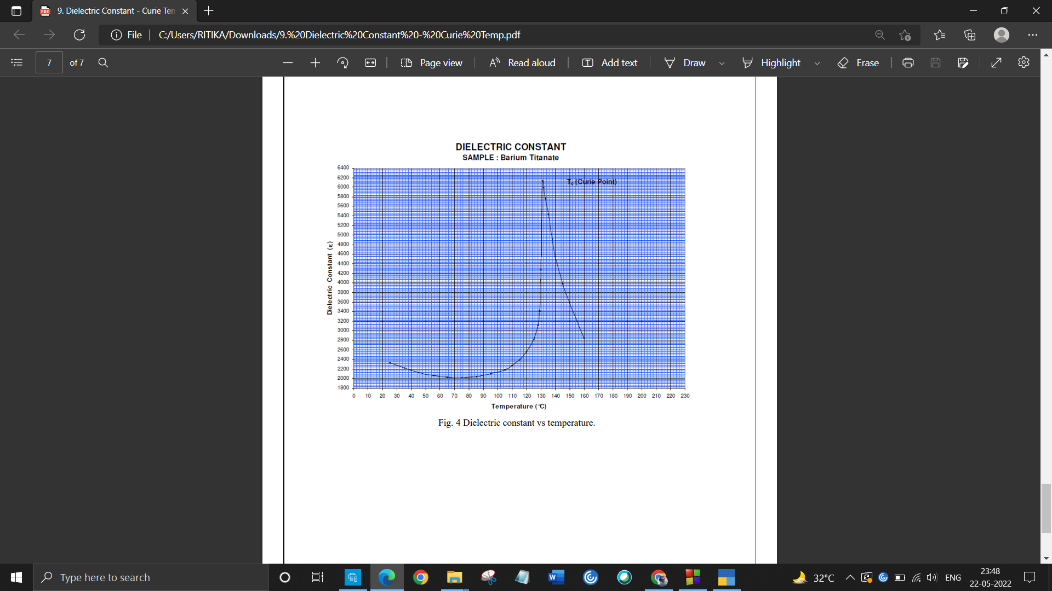

Curie’s Temperature ($T_{c}$) = 129 ${}_{}^{0}C$

**REFERENCES**

https://www.iiserkol.ac.in/~ph324/ExptManuals/DielectricConstant.pdf